Nama : Kenzie Maheswara Tama
JDT Batch 17

Normalization Study Case
ERD:
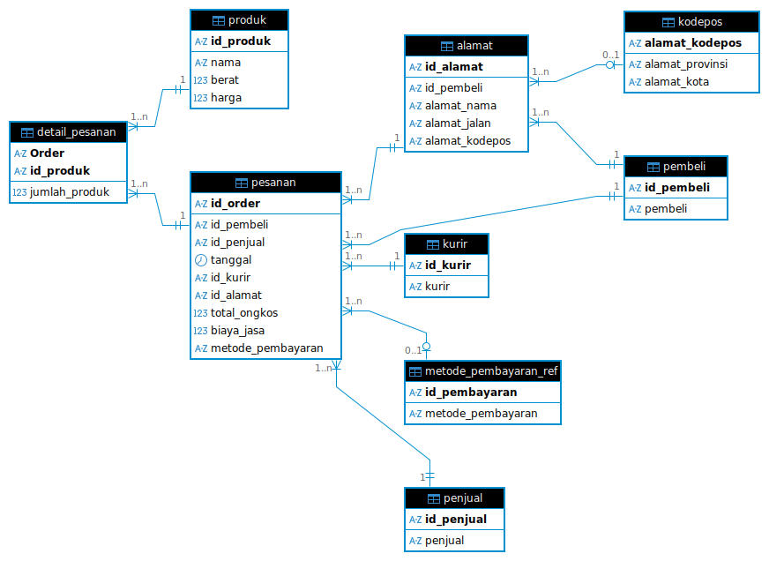

DDL:
CREATE TABLE penjual (
id_penjual VARCHAR(50) PRIMARY KEY,
penjual VARCHAR(255) NOT NULL
);

CREATE TABLE metode_pembayaran_ref (
id_pembayaran VARCHAR(50) PRIMARY KEY,
metode_pembayaran VARCHAR(100) NOT NULL
);

CREATE TABLE produk (
id_produk VARCHAR(50) PRIMARY KEY,
nama VARCHAR(255) NOT NULL,
berat INT,
harga NUMERIC(12, 2) NOT NULL
);

CREATE TABLE pembeli (
id_pembeli VARCHAR(50) PRIMARY KEY,
pembeli VARCHAR(255) NOT NULL
);

CREATE TABLE kurir (
id_kurir VARCHAR(50) PRIMARY KEY,
kurir VARCHAR(100) NOT NULL
);

CREATE TABLE kodepos (
alamat_kodepos VARCHAR(20) PRIMARY KEY,
alamat_provinsi VARCHAR(100) NOT NULL,
alamat_kota VARCHAR(100) NOT NULL
);

-------------------------------------------------------------------------------

CREATE TABLE alamat (
id_alamat VARCHAR(50) PRIMARY KEY,
id_pembeli VARCHAR(50) NOT NULL,
alamat_nama VARCHAR(100),
alamat_jalan TEXT,
alamat_kodepos VARCHAR(20),
CONSTRAINT fk_alamat_pembeli
FOREIGN KEY (id_pembeli)
REFERENCES pembeli(id_pembeli),
CONSTRAINT fk_alamat_kodepos
FOREIGN KEY (alamat_kodepos)
REFERENCES kodepos(alamat_kodepos)
);

CREATE TABLE pesanan (
id_order VARCHAR(50) PRIMARY KEY,
id_pembeli VARCHAR(50) NOT NULL,
id_penjual VARCHAR(50) NOT NULL,
tanggal DATE NOT NULL,
id_kurir VARCHAR(50) NOT NULL,
id_alamat VARCHAR(50) NOT NULL,
total_ongkos NUMERIC(12, 2),
biaya_jasa NUMERIC(12, 2),
metode_pembayaran VARCHAR(50),
CONSTRAINT fk_pesanan_pembeli
FOREIGN KEY (id_pembeli) REFERENCES pembeli(id_pembeli),
CONSTRAINT fk_pesanan_penjual
FOREIGN KEY (id_penjual) REFERENCES penjual(id_penjual),
CONSTRAINT fk_pesanan_kurir
FOREIGN KEY (id_kurir) REFERENCES kurir(id_kurir),
CONSTRAINT fk_pesanan_alamat
FOREIGN KEY (id_alamat) REFERENCES alamat(id_alamat),
CONSTRAINT fk_pesanan_pembayaran
FOREIGN KEY (metode_pembayaran) REFERENCES metode_pembayaran_ref(id_pembayaran)
);

CREATE TABLE detail_pesanan (
"Order" VARCHAR(50),
id_produk VARCHAR(50),
jumlah_produk INT NOT NULL,
PRIMARY KEY ("Order", id_produk),
CONSTRAINT fk_detail_order
FOREIGN KEY ("Order")
REFERENCES pesanan(id_order),
CONSTRAINT fk_detail_produk
FOREIGN KEY (id_produk)
REFERENCES produk(id_produk)
);

-- 1. Populate Reference Tables

INSERT INTO penjual (id_penjual, penjual) VALUES
('GO', 'Galeri Olahraga'),
('HS', 'Hello Store');

INSERT INTO metode_pembayaran_ref (id_pembayaran, metode_pembayaran) VALUES
('DO', 'Debit Online'),
('CC', 'Credit Card');

INSERT INTO produk (id_produk, nama, berat, harga) VALUES
('P0001', 'Bola Basket Size 7', 2300, 177900.00),
('P0002', 'Bola Basket Size 5', 500, 98900.00),
('P0003', 'Pentil Pompa Bola', 54, 9900.00),
('P0004', 'Pompa Bola', 198, 43900.00),
('P0005', 'Apple iPhone Pro Max', 1000, 25000000.00),
('P0006', 'Apple Watch 8', 2000, 8000000.00);

INSERT INTO pembeli (id_pembeli, pembeli) VALUES
('JM', 'Joko Morro'),
('EK', 'Eko Kurniawan');

INSERT INTO kurir (id_kurir, kurir) VALUES
('SCG', 'Sicepat - Gokil'),
('JNE', 'JNE');

INSERT INTO kodepos (alamat_kodepos, alamat_provinsi, alamat_kota) VALUES
('433333', 'DKI Jakarta', 'Jakarta'),
('432434', 'Jawa Barat', 'Bandung');

-- 2. Populate Dependent Tables

-- Addresses (Relies on Pembeli and Kodepos)
INSERT INTO alamat (id_alamat, id_pembeli, alamat_nama, alamat_jalan, alamat_kodepos) VALUES
('BN', 'JM', 'Budi Nugraha', 'Jalan raya xxx', '433333'),
('RL', 'EK', 'Rully', 'Jalan raya baru', '432434');

-- Orders (Relies on Pembeli, Penjual, Kurir, Alamat, and Pembayaran)
INSERT INTO pesanan (id_order, id_pembeli, id_penjual, tanggal, id_kurir, id_alamat, total_ongkos, biaya_jasa, metode_pembayaran) VALUES
('12345', 'JM', 'GO', '2023-04-11', 'SCG', 'BN', 60000.00, 1000.00, 'DO'),
('11111', 'EK', 'HS', '2023-04-12', 'JNE', 'RL', 100000.00, 1000.00, 'CC'),
('22222', 'JM', 'GO', '2023-04-13', 'SCG', 'BN', 60000.00, 1000.00, 'DO');

-- Order Items (Relies on Pesanan and Produk)
INSERT INTO detail_pesanan ("Order", id_produk, jumlah_produk) VALUES
('12345', 'P0001', 2),
('12345', 'P0002', 1),
('12345', 'P0003', 1),
('12345', 'P0004', 1),
('11111', 'P0005', 1),
('11111', 'P0006', 1),
('22222', 'P0001', 1);

